2013-2014 FINAL APR FORM INSTRUCTIONS
Step 1 (Optional): We strongly recommend utilizing the attached 2013-2014 APR Worksheet prior to entering the APR information into Google Forms so you can easily copy and paste your data into the form. Google Forms does not save the information entered until the data is submitted, and so we have created this helpful worksheet for programs to use so you can enter the data into the form in one sitting.
Step 2: Click this link to access the form: 2013-2014 FINAL APR FORM
Step 3: Complete each page in the report. You will be able to move around from page to page, but you cannot save your work until you hit submit at the very end of the report. The instructions for saving your work are listed below in Step 4. Be sure to answer all of the required questions. For entire pages that are required, it is indicated in the instructions of each page. For pages that have a combination of optional and required questions, “[REQUIRED]” is listed within the question field.
*IMPORTANT*: In order to complete the APR Report in stages, as opposed to entering all the data in at one time, you MUST follow the instructions below. This will also allow you to easily access and update your mid-year report for Final APR submission.
- When you finish the report, the following screen will appear:
- Click the check box and hit SUBMIT:
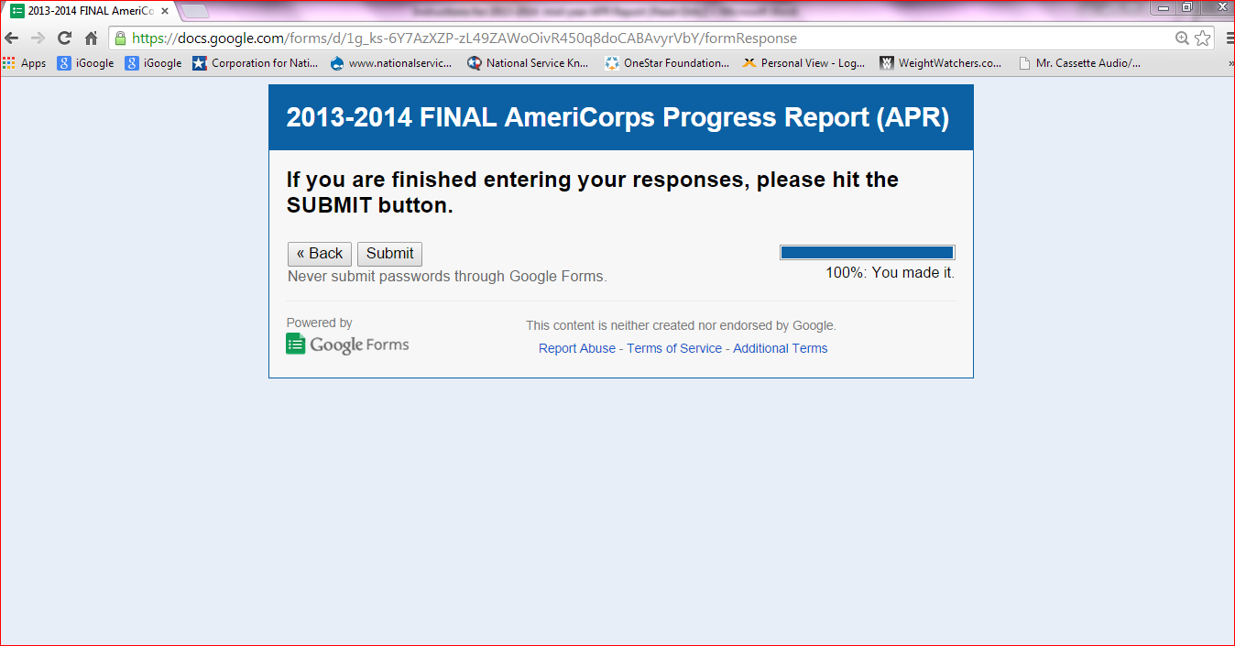

B. After you hit SUBMIT, the following screen will appear:
- You must click the “EDIT YOUR RESPONSE” option. DO NOT CHOOSE “Submit another response.”
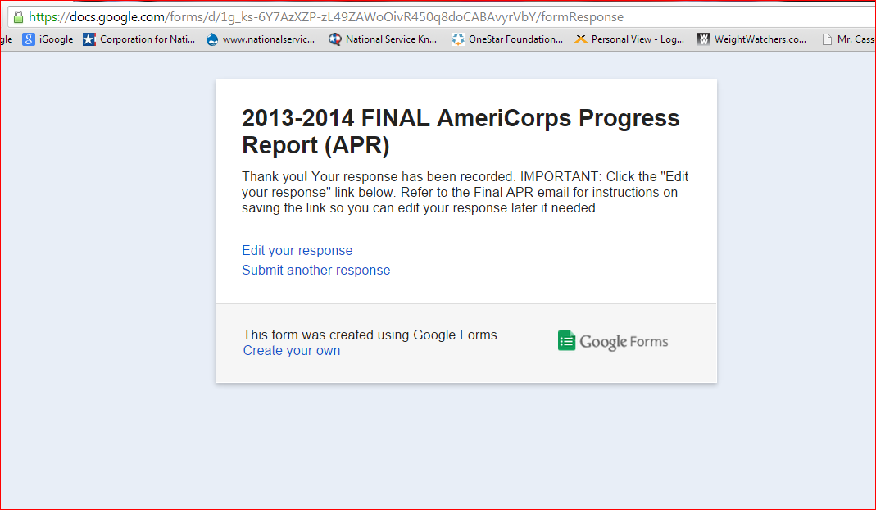

4. Once you click “EDIT YOUR RESPONSE,” the following screen will appear:
- It is very important that you copy the circled link below and save it somewhere where you will not lose it. This is the only way to access your report if you want to be able to edit it at a later time. We strongly encourage programs to email this link to their Programmatic Grants Officer, and we will keep track of the saved links for future access. In order to copy the link, you will hover your cursor over the URL, right click your mouse, click “copy,” and then paste it where you won’t lose it.
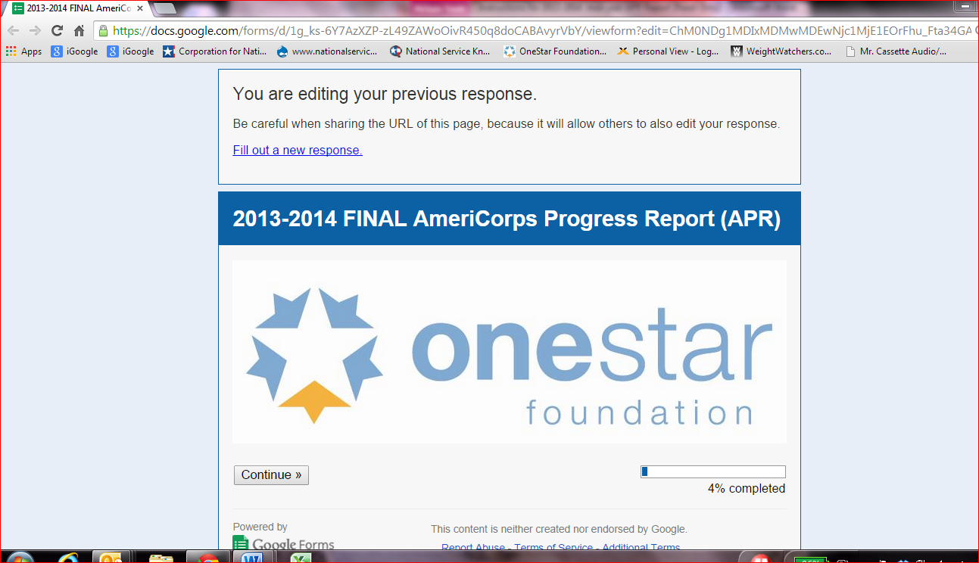

5. You will then be able to edit your report and re-submit at a later date if needed:
