From the deobligation portion of the mid-year FFR:
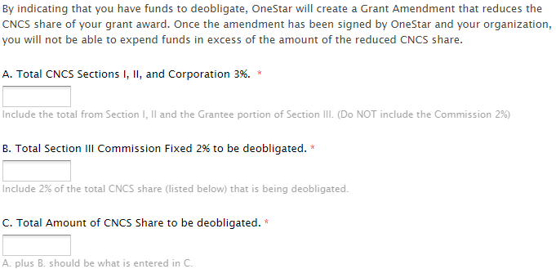
Scenario 1)
TatooineCorps Program Staff tell you that they will underspend on Sections I and Section II because one of the counsellors retired and 2 members ended their service early for grad school. Her estimate is that $30,000 will be unspent between the two sections. What is the total to deobligate for Sections I, II, and III Corporation Share 3%?

Scenario 2)
Naboo Math Corps received a generous in-kind donation from a corporate partner. The items were initially within the CNCS Share of the budget. Rather than finding alternative items to spend the dollars on, they prefer to deobligate funds. The total amount to deobligate is $75,000. What is the amount of for boxes A and B on the deobligation form?

