Understanding AmeriCorps Member Enrollment and Exit Cycle Time Reports

The Enrollment Approval Cycle Time Report and Exit Approval Cycle Time Reports can be used to assess compliance with 30-day enrollment and exit requirements and are available from the Reports menu in the eGrants Portal.

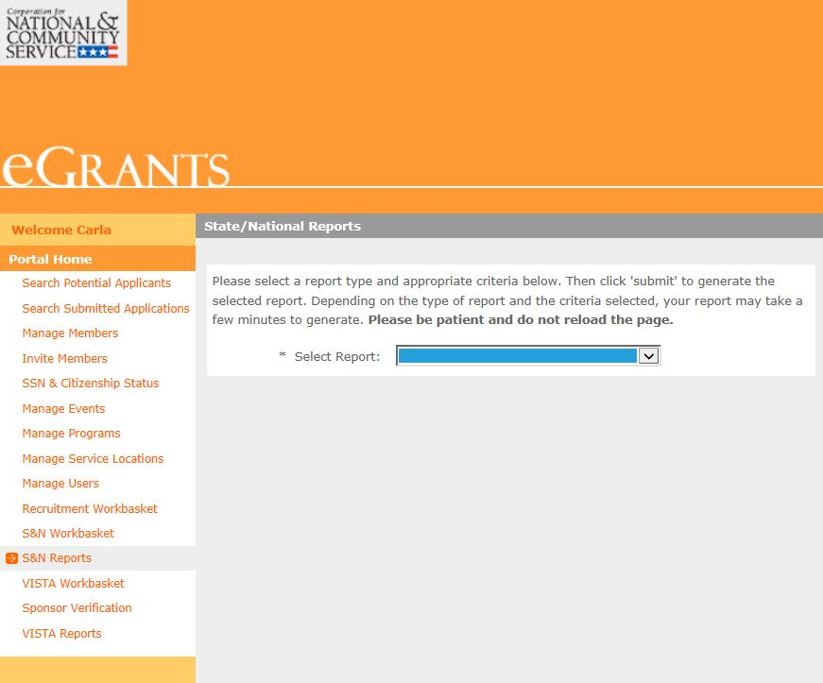

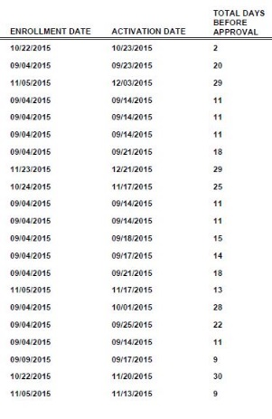
In these reports, the “Total Days Before Approval” number is used to assess compliance. Thirty-one days, and any number of days less than 31 days, is considered compliant. To understand how 31 days can be considered compliant when the requirement is 30 days, it helps to understand how the Portal calculates this number.

If you were to count the number of days between now (if today is Tuesday) and Saturday, you would count Wednesday, Thursday, Friday, and Saturday—a total of four days. However, instead of counting four days, the Portal includes the current day—Tuesday, Wednesday, Thursday, Friday, and Saturday—a total of five days. Because the Portal adds an extra day to its calculation, 31 days actually means the AmeriCorps member was enrolled or exited within 30 days.

