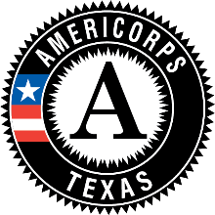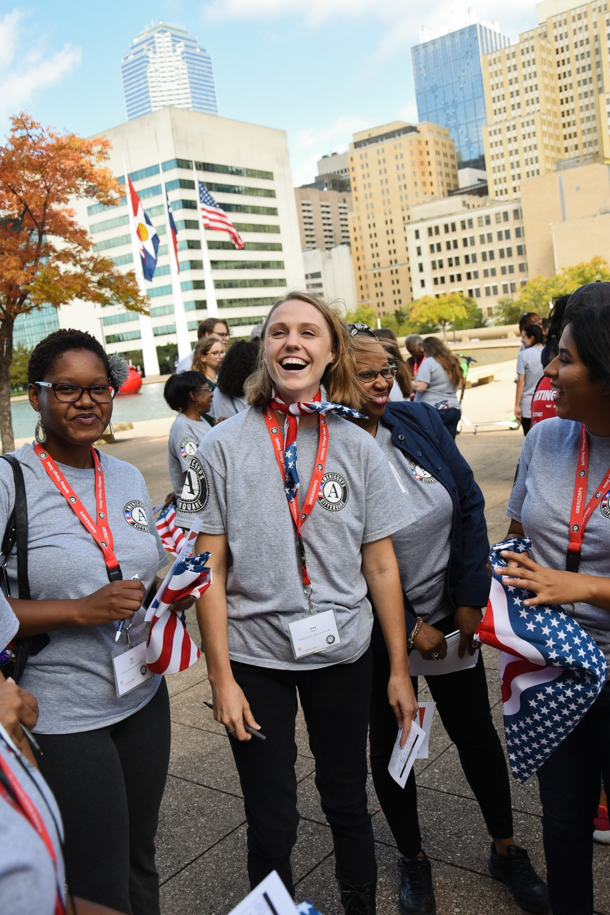

**On September 21, 1993, on the South Lawn of the White House, President Bill Clinton signed H.R. 2010, Public Law No. 103-82, creating both the Corporation for National and Community Service and AmeriCorps. He was joined by Vice President Gore, Eli Segal, original members of President Roosevelt’s Civilian Conservation Corps, Peace Corps Director Carol Bellamy, Sargent Shriver, service corps participants from across the country, recent Summer of Service participants, and individuals who had invested their time and talents to lay a foundation for national service.**

**One year later, on September 12, 1994, the first class of AmeriCorps members took the pledge to “get things done” for America on the North Portico of the White House and in simultaneous locations across the country. Today we conclude the commemoration of 25 years of AmeriCorps making a difference in communities across our country.**



AMERICORPS 25TH ANNIVERSARY CELEBRATION

**[Venue] ★ [City, State]**

**[Date]**

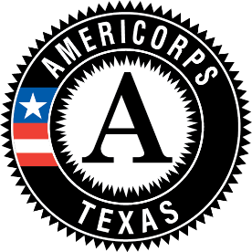

**AmeriCorps 25th Anniversary Celebration**

[Venue] ★ [City, State]

[Date]

[Use this page for announcements, acknowledgments, speaker bios, photos, or any additional information for attendees.]

# SPECIAL THANKS TO

**Supporter**

**Supporter**

**Supporter**

**Supporter**

# SPEAKER BIOS

**Speaker Name**

SPEAKER POSITION

Enter speaker bio here.

**Speaker Name**

SPEAKER POSITION

Enter speaker bio here.

**Speaker Name**

SPEAKER POSITION

Enter speaker bio here.

**Speaker Name**

SPEAKER POSITION

Enter speaker bio here.

# ANNOUNCEMENTS

**Announcement**

**Announcement**

**Announcement**

**Announcement**

# 

# **Ceremony** AMERICORPS 25TH ANNIVERSARY

**Event**

SPEAKER

**Event**

SPEAKER

**Event**

SPEAKER

**Event**

SPEAKER

**Event**

SPEAKER

**Event**

SPEAKER